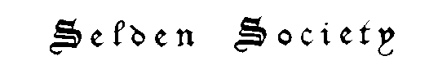
Founded 1887

To encourage the study and advance the knowledge of the history of English law

Joining the Selden Society

The best way to acquire Selden Society volumes is to become a member. For the annual subscription a member receives without further charge the annual volume, the annual report of the Council of the Society, and occasional literature including published lectures. A member is also entitled to concessionary rates on the Society’s Supplementary Series volumes. And by arrangement with HeinOnline, members may access Selden Society volumes other than very recent ones by means of a password.

To join the Society, complete the form below and mail it to Professor Tate at the address indicated.

Please note that this form is for US individual memberships only.

Selden Society US Individual Membership Application Form

Professor Joshua Tate
Hon. Secretary, Selden Society
SMU Dedman School of Law
3315 Daniel Avenue
Dallas TX 75205
(214) 768-2791

I apply to become a member of the Selden Society. I send $65.00 in payment of my dues
for the current year.

NAME…………………………………………………………………………………..

ADDRESS………………………………………………………………………………

…………………………………………………………………………………………..

E-MAIL ADDRESS…………………………………………………………………….

SIGNED…………………………………………

DATE…………………………………………….

